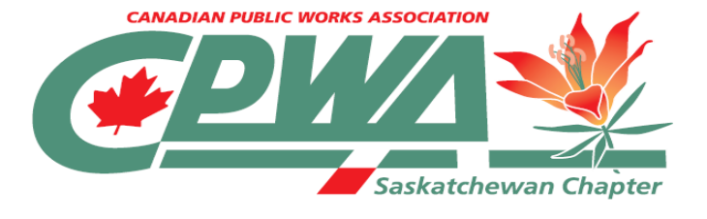
Sponsorship Form
Fall 0.6 CEU Workshop
Paving Over Problems
Wednesday October 21, 2026
Connexus Arts Centre Regina, SK

Fall 0.6 CEU Workshop
Paving Over Problems

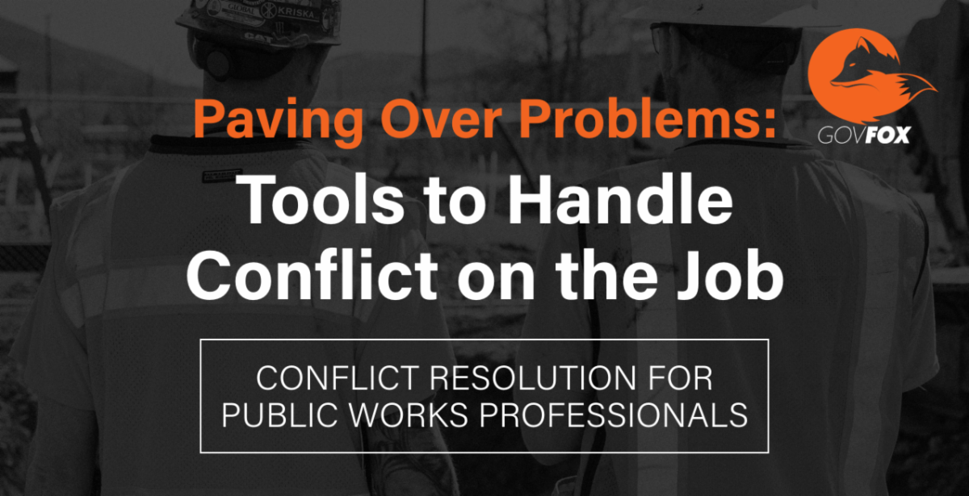

REGISTRATION REPLY REQUESTED PRIOR TO JANUARY 14, 2022

Sponsorship
Name:

Cell Phone: Office Phone: FAX:

Email: ____________________________________________________________________________

Community of Employment or Business name: _________________________________________________

Workshop Sponsorship : $500.00

Please indicate if paying by: Cheque Visa MasterCard

Name on card: ________________________________________ Expiry Date: ________________

Card Number: _______________/________________/_________________/_________________

If paying by credit card, you MUST mail, phone, or fax in your credit card information. Do Not Email.

TOTAL FEE ENCLOSED: $

Vision: Empowering Saskatchewan Public Works teams through strong municipal networking and knowledge sharing.
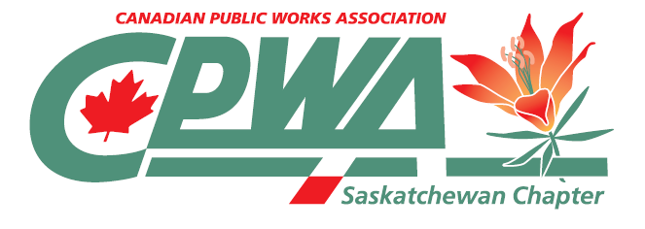
Mission: Connect those who operate, improve, and maintain public works and infrastructure with an easily accessible platform to network, share information, exchange ideas, and support each other.
Submit Registration Form to:
Kristine Olson, Chapter Administrator
Saskatchewan Public Works Association (SPWA)
P.O. Box 131, Saskatoon, SK S7K 3K4
Ph: (306) 705-7792 Email: spwa@sasktel.net

